V1
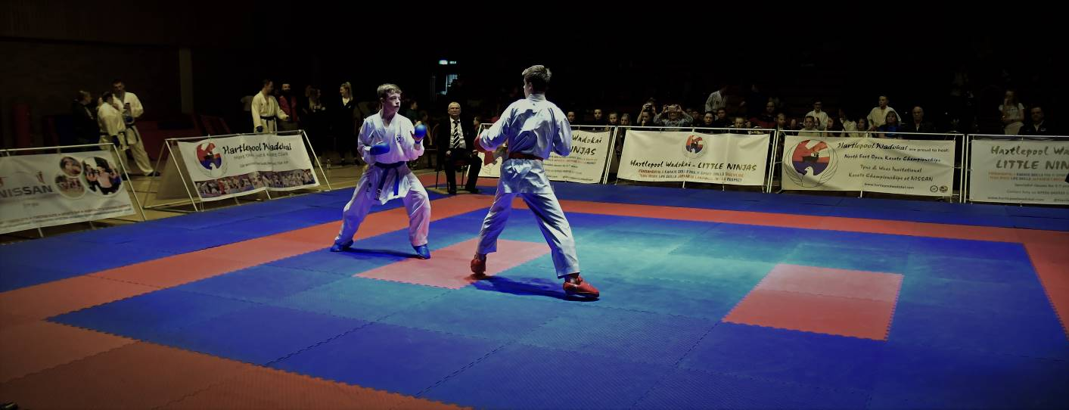

North East Open Karate Championships
Walker Activity Dome, Wharrier St, Newcastle upon Tyne, NE6 3BR

Sunday 11th May 2025

Doors open 08:30am, 09:00am start

We have fantastic awards
for 1st, 2nd and joint 3rd position

Closing date for entries Sunday 4th May
Strictly NO ENTRIES on the day – entries will be capped so please get yours in early

Event organiser: Carl Jorgeson  Tel: 07984 798634  Email: northeastopen@gmail.com | 2025 Dates  3rd August; 9th November

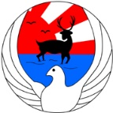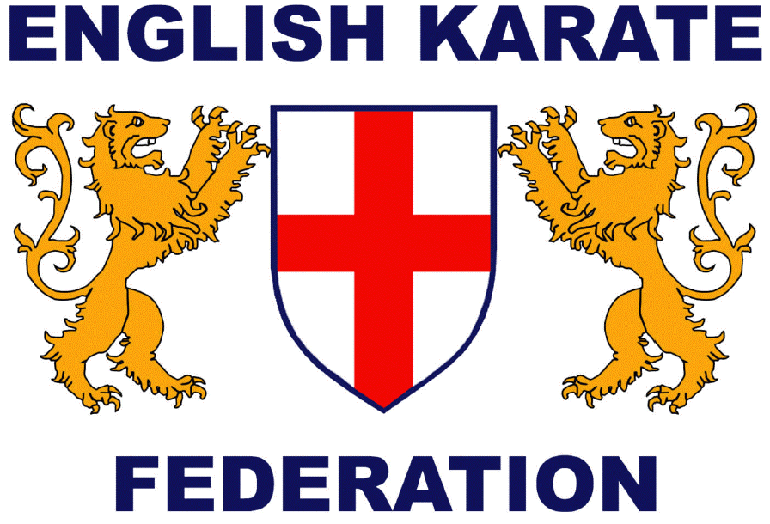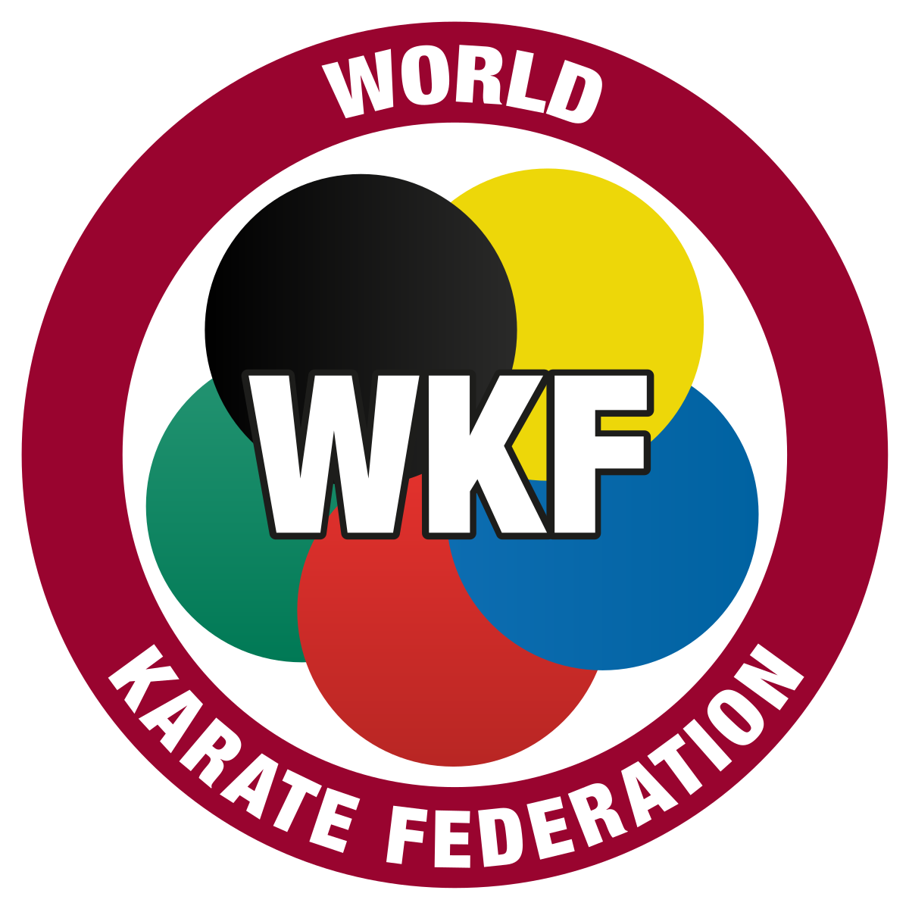

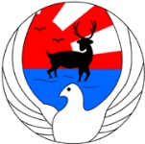
North East Open Karate Championships

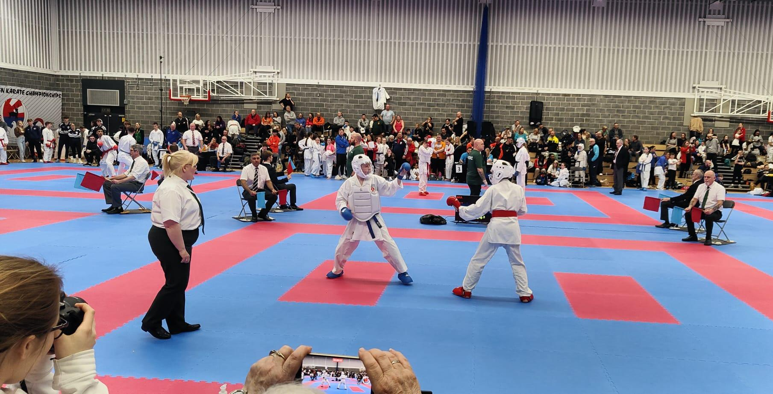

WELCOME

On behalf of the organising team, I would like to welcome you to the North East of England for our first 2025 North East Open Karate Championships. I hope you get to see some of the amazing local sights during the championships weekend (take a look at visitnortheastengland.com for some inspiration).

I’d like to highlight that the North East Open CIC is a non-profit company, set-up and managed by Hartlepool Wadokai, our non-profit Karate club. Every penny raised gets reinvested back into the sport and the wider community. We have invested significantly into the event infrastructure in recent years and that is only possible thanks to the continued support of athletes, coaches and parents so thank you very much.

2025 sees us moving to a new venue, and a new city, taking advantage of the international airport (& more hotels) that Newcastle boasts of.

Good Luck to all athletes and coaches and thank you once again for the continued support.

Yours sincerely

Carl Jorgeson
Tournament Director

North East Open Karate Championships

KATA CATEGORIES

KATA RULES
- Competitors may enter the next category up in their age group, if they wish to compete using advanced Kata.
- No Bunkai in teams
- Children’s sections will be performed 2 athletes at a time, including finals
- Flags will be used for all none-WKF sections, points may be used for WKF sections
- Wado Kata sections – only Wado Kata may be used
- Wado athletes can also enter the ‘open’ sections

ALL CLUBS MUST NOTE THE FOLLOWING:
This competition is open to any club or association in compliance with the rules and regulations of the World Karate Federation. Any club / association not in direct membership to the EKF or equivalent must declare to the effect that they do not belong to an opposing world body in contravention of WKF statute 21.9.

North East Open Karate Championships

KUMITE CATEGORIES

Non-WKF Kumite sections MIGHT also be split by weight (depending on entry size), weights must be included for fighters on entry forms.
Any under-subscribed categories may be merged with another or cancelled, and any oversubscribed categories may be split without prior notice at the discretion of the event organiser.

Official Protest
An official protest will cost £50 and must be accompanied by a completed and signed protest form.

The organisers reserve the right to amend/alter any rules without prior notice.

North East Open Karate Championships

KUMITE RULES
All 9 years & under matches to be 1 minute, All 10-13 years to be 1.5 minutes.
All Cadets, Juniors & Veterans to be 2 minutes, All Senior Male & Senior Female Kumite to be 3 minutes.
All teams are to be three persons (min 2). Bout times for teams may be reduced.
No head or face contact in 13yrs & under age groups. No Repechage in any section.

WKF (2025) rules will be applied (https://www.wkf.net/structure-statutes-rules)

Kick Master Kumite – KU1a, KU1b, KU1c
This consists of each competitor simultaneously attacking their respective red or blue kick post for 30 seconds.

The competitor who is judged to have attacked most vigorously, most skilfully and most powerfully will be awarded the win. All Karate techniques can be used. Impact with the pad is expected. Three flag system as in kata.

Pricing
Individual Events | £25.00 |  | Spectators | £10.00,
Kick Master | £20.00 |  | Children Under 5's | FREE
Pairs | £30.00
Teams | £35.00

Essential Equipment
All competitors to wear a clean white traditional Karate Gi, as per WKF rules.
Red and Blue belts are compulsory for all events., with Kumite events also requiring the following:
- Red and Blue mitts and Gum Shields.
- Body protectors or integrated Body & Chest Protectors for females, all of WKF style.
- Body protectors for males, all of WKF style.
- WKF style shin and foot protectors are compulsory for all competitors 10 years and above. Cotton type glove or shin and foot protectors are not permitted.
- Please note that Headguards MUST now be worn by all children 13 years and below as mandated by the World, British and English Karate Federations. We have purchased kit to make available at the event for those who don’t yet have their own. They will be cleaned between use.

Licence Checks
Licence checks will be done at the discretion of the event organiser. Failure to produce a valid licence when requested will mean disqualification from all categories. Please don’t forget them!

Weight Checks
Please note that weigh-in for kumite competitors will be open from 11am. The organisers reserve the right to refuse entry to competitors failing to make their weight sections, with no refund offered. Competitors must wear their Karate suit for weight checks. It is the responsibility of coaches to ensure competitors are entered in their correct age & weight sections.

Transgender & Transsexual Athletes
Guidance around Transgender and Transsexual athletes is constantly being updated. Please refer to the English Karate Federation Transgender and Transsexual Policy for the latest guidance.

Submitting entries
Please use the official entry form for submitting ALL entries, this is available in PDF & MS word format. If we only receive a list of names and category numbers, we are unable to check for errors. It is the responsibility of coaches to ensure competitors are entered into the correct sections. Athletes must only compete in their own age group, including team/pair events. Please submit entries via email and pay in advance via BACS. All entries are provisional until payment is received.
North East Open Karate Championships

HOTEL INFORMATION

Premier Inn  Newcastle City Centre (Millenium Bridge)  Approx 2 miles / 7 mins from the venue | 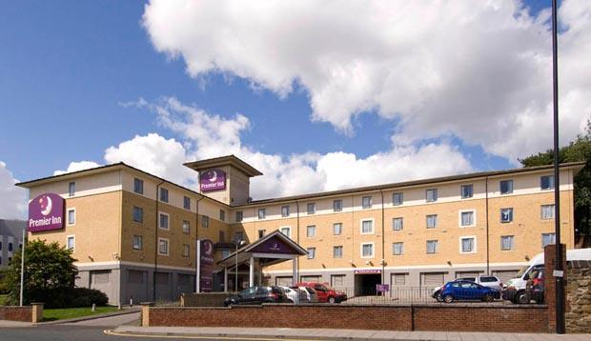
https://www.premierinn.com/gb/en/hotels/england/tyne-and-wear/newcastle/newcastle-city-centre-millennium-bridge.html
Premier Inn  Newcastle City Centre (The Gate)  Approx 4 miles / 20 mins from the venue | 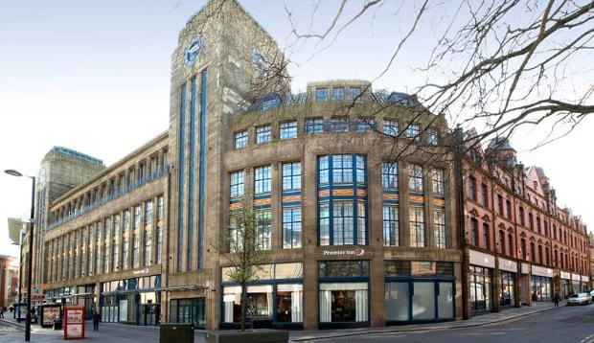
https://www.premierinn.com/gb/en/hotels/england/tyne-and-wear/newcastle/newcastle-city-centre-the-gate.html

Hilton Newcastle Gateshead  Approx 3 miles / 15 mins from the venue | 
https://www.hilton.com/en/hotels/nclhihi-hilton-newcastle-gateshead/

AIRPORTS
The nearest airports are Newcastle International (approx. 20mins) or Teesside International (approx. 60mins).

North East Open Karate Championships

INDIVIDUAL ENTRY FORM

Club / Dojo Name:
Club / Dojo Chief Instructor:
Instructor contact number:

Name | Sex | Age | DOB | Grade | Weight (kg) | Enter Category codes (individual Kata & Kumite only) |  |  |  |  |  |  |  | Entry Fees
 |  |  |  |  |  | Use the separate sheets for Kick Master, Pairs & Teams |  |  |  |  |  |  |  | Entry Fees
 |  |  |  |  |  |  |  |  | Total Entry Fees:
Disclaimer
"The competitor realises and discharges the organisers and their representatives or agents and all other competitors from all claims that the competitor or his personal representative may have for any injury (however caused) sustained by the competitor and for the loss or damage (however caused) to his personal belongings suffered at any time during the course of the Championships or while on the premises at which the Championships are being held".

Signed (Chief Instructor): |  | Date:

Closing date for all entries 4th May
BACS: ‘North East Open CIC’ Sort Code 608371, Account No 31475810, Reference: Club/Association
International Payments: IBAN: GB07SRLG60837131475810 BIC: SRLGGB2L
Please make all cheques payable to ‘North East Open CIC’ and email to: northeastopen@gmail.com (Post – if applicable: 4 Gladstone Street, Hartlepool, TS24 0PE)
North East Open Karate Championships

INDIVIDUAL ENTRY FORM

Club / Dojo Name:
Club / Dojo Chief Instructor:
Instructor contact number:

Name | Sex | Age | DOB | Grade | Weight (kg) | Enter Category codes (individual Kata & Kumite only) |  |  |  |  |  |  |  | Entry Fees
 |  |  |  |  |  | Use the separate sheets for Kick Master, Pairs & Teams |  |  |  |  |  |  |  | Entry Fees
 |  |  |  |  |  |  |  |  | Total Entry Fees:
Disclaimer
"The competitor realises and discharges the organisers and their representatives or agents and all other competitors from all claims that the competitor or his personal representative may have for any injury (however caused) sustained by the competitor and for the loss or damage (however caused) to his personal belongings suffered at any time during the course of the Championships or while on the premises at which the Championships are being held".

Signed (Chief Instructor): |  | Date:

Closing date for all entries 4th May
BACS: ‘North East Open CIC’ Sort Code 608371, Account No 31475810, Reference: Club/Association
International Payments: IBAN: GB07SRLG60837131475810 BIC: SRLGGB2L
Please make all cheques payable to ‘North East Open CIC’ and email to: northeastopen@gmail.com (Post – if applicable: 4 Gladstone Street, Hartlepool, TS24 0PE)
North East Open Karate Championships

KICKMASTER ENTRY FORM ONLY

Club / Dojo Name:
Club / Dojo Chief Instructor:
Instructor contact number:

KICKMASTER entry fee is £20.00 per person,
Name | Sex | Age | DOB | Grade | Category number | Entry Fees
 |  | Total Entry Fees:

North East Open Karate Championships

PAIRS / TEAM KATA ENTRY FORM

Club / Dojo Name:
Club / Dojo Chief Instructor:
Instructor contact number:

PAIRS KATA If more than one team please name then A, B, C etc…
CAT NO | Team Name | Competitor 1 | Competitor 2
 |  | Total | £

TEAM KATA If more than one team please name then A, B, C etc…
CAT NO | Team Name | Competitor 1 | Competitor 2 | Competitor 3
 |  |  | Total | £

North East Open Karate Championships

TEAM KUMITE ENTRY FORM

Club / Dojo Name:
Club / Dojo Chief Instructor:
Instructor contact number:

TEAM KUMITE If more than one team please name then A, B, C etc…
CAT NO | Team Name | Competitor 1 | Competitor 2 | Competitor 3
 |  |  | Total | £

 |  | £
Total individual entries | ____ @ £25.00
Total Kick Master entries | ____ @ £20.00
Total Pairs Kata entries | ____ @ £30.00
Total Team entries | ____ @ £35.00
 | Total

Closing date for all entries 4th May
BACS: ‘North East Open CIC’ Sort Code 608371, Account No 31475810, Reference: Club/Association
International Payments: IBAN: GB07SRLG60837131475810 BIC: SRLGGB2L
Please make all cheques payable to ‘North East Open CIC’ and email to: northeastopen@gmail.com (Post – if applicable: 4 Gladstone Street, Hartlepool, TS24 0PE)
North East Open Karate Championships

LIST OF ALL COMPETITORS
Please complete and return this page as it allows us to double check for admin errors

Children |  | Children |  | Ladies |  | Men
1 |  | 16 |  | 1 |  | 1
2 |  | 17 |  | 2 |  | 2
3 |  | 18 |  | 3 |  | 3
4 |  | 19 |  | 4 |  | 4
5 |  | 20 |  | 5 |  | 5
6 |  | 21 |  | 6 |  | 6
7 |  | 22 |  | 7 |  | 7
8 |  | 23 |  | 8 |  | 8
9 |  | 24 |  | 9 |  | 9
10 |  | 25 |  | 10 |  | 10
11 |  | 26 |  | 11 |  | 11
12 |  | 27 |  | 12 |  | 12
13 |  | 28 |  | 13 |  | 13
14 |  | 29 |  | 14 |  | 14
15 |  | 30 |  | 15 |  | 15

Declaration
I confirm that all the competitors have been advised of and will comply with the conditions of entry. I have also advised all the competitors of the potential risk of competition karate and they fully realise and accept these risks. All competitors hold a valid licence and insurance.

Signed (Chief Instructor): |  | Date:
This must be signed or the entry won’t be accepted.

Club Name:
Club Postal Address
inc postcode:
Tel: |  | Email:
Please submit this entry form via email to northeastopen@gmail.com

Please ensure you provide a valid email address so that we can send through updates and the running orders.

